National School Backpack Awareness Day
(YOUR SCHOOL NAME)
(CONTACT EMAIL)

Problem Statement: The goal is to learn if kids at (YOUR SCHOOL) are carrying backpacks that are too heavy for their frames during these fundamental years of growth and bone development. Professional recommendations (APTA, AOTA) are that a pack should weigh no more than 10-15% of bodyweight. Research has shown that the potential long term impact is neck, back and shoulder pain along with changes in posture that could make it difficult for muscles and ligaments to hold the body up properly.

Purpose of Event: On (DATE), (YOUR SCHOOL) hosted this event to educate kids on the best type of backpack to purchase and how to wear and pack their backpacks. Additionally, students had the option of having their backpacks weighed and data recorded. This was a first step toward quantifying the magnitude and prevalence of the heavy backpacks.

What We Learned: (INSERT YOUR DATA –NEEDS TO BE CUSTOMIZED)
● 48% of students participated in getting packs weighed on the morning of 9/16 (272 kids)
● Across 6-8th grades the average backpack weight was over 16 pounds
● The % of bodyweight the pack consumes is greater in younger grades, b/c kids weights
vary by roughly 20 pounds from 6-8th grade(based on CDC data), but even so…
● 96% of the students that participated had backpacks that are OUTSIDE of the “Safe Zone”

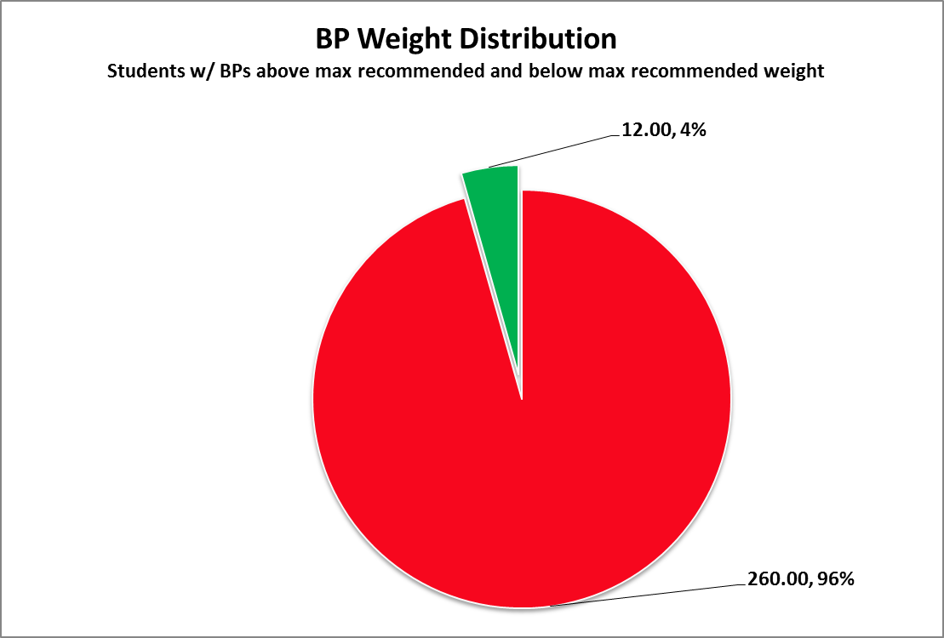

Females:
Grade | Avg. BP Weight | Avg. Fem. Weight | #measured | #pounds over 12.5% | %body Weight
6 | 16.11045 | 81.5 | 44 | 5.93 | 0.197674
7 | 16.12989 | 91.5 | 60 | 4.69 | 0.176283
8 | 16.05603 | 101 | 33 | 3.49 | 0.158971
The average female 6th grader is carrying almost 20% of her bodyweight on her back. That is equivalent to a 190 lb man carrying around 38 pounds. That’s equal to 10 bricks, 5 gallons of water, or 6 reams of paper!

Next steps: The data is conclusive that a large percentage of our student population is carrying too much weight on their backs. The (SCHOOL) Backpack Committee, in partnership with (SCHOOL) leadership and district administration need to prioritize the importance of this safety issue, and explore viable options for lightening backpack weights and implement a solution(s) in a timely manner.

